Unit-1
Introduction: Distributed Data Processing
Distributed Data Processing refers to the technique of processing large volumes of data across multiple computers or servers rather than relying on a single machine. This approach enhances scalability, fault tolerance, and efficiency, making it ideal for handling big data applications.

Key Aspects of Distributed Data Processing:
- Parallelism – Tasks are split into smaller parts and processed simultaneously across multiple nodes.
- Scalability – Systems can handle increasing workloads by adding more computing resources.
- Fault Tolerance – Distributed systems can recover from node failures without data loss.
- Data Locality – Processing is moved closer to where data is stored, reducing network latency.
- Coordination & Synchronization – Mechanisms like distributed file systems and consensus algorithms manage consistency.

Common Frameworks:
- Hadoop – Uses the MapReduce model for batch processing.
- Apache Spark – Provides fast in-memory processing for big data.
- Flink & Storm – Designed for real-time stream processing.
Introduction of Distributed Database System
A Distributed Database System (DDBS) is a collection of interconnected databases spread across multiple locations but appearing as a single unified system. It enables efficient data management, improved performance, and fault tolerance in large-scale applications.

Key Characteristics:
- Data Distribution – Data is stored across multiple sites but remains accessible as a single database
- Transparency – Users interact with the system without needing to know data locations.
- Scalability – Supports growing data and user demands by adding more nodes.
- Replication & Fragmentation – Data can be replicated for redundancy or split (fragmented) for efficiency.
- Concurrency Control – Ensures consistency when multiple users access data simultaneously.

Types of Distributed Databases:
- Homogeneous – All databases use the same DBMS.
- Heterogeneous – Different DBMSs are used but are integrated.

Advantages:
- Improved reliability & fault tolerance.
- Faster data access & reduced network congestion.
- Better resource utilization & scalability

Promises of DDBSs, Problem areas

Promises of DDBSs:
- Improved Performance – Queries run faster by distributing workload across multiple sites.
- Scalability – Easily expands by adding more nodes without major system redesign.
- Fault Tolerance & Reliability – Data replication ensures system continues functioning even if some nodes fail.
- Better Resource Utilization – Optimizes computing power by distributing tasks efficiently.
- Data Localization – Reduces network traffic by processing data closer to where it is needed.
- Autonomy & Flexibility – Different sites can operate independently while still being part of the system.

Problem Areas of DDBSs:
- Complexity – Managing distributed databases requires advanced coordination mechanisms.
- Data Consistency – Ensuring consistency across multiple sites is challenging.
- Security Concerns – Data spread across different locations increases vulnerability to breaches.
- High Communication Overhead – Synchronizing distributed data generates significant network traffic.
- Query Optimization Issues – Efficient query processing across distributed sites is complex.
- Concurrency Control – Preventing conflicts when multiple users access data simultaneously is difficult.

Distributed DBMS Architecture: Architectural Models for Distributed DBMS
Some of the common architectural models are −
- Client - Server Architecture for DDBMS
- Peer - to - Peer Architecture for DDBMS
- Multi - DBMS Architecture
- Client - Server Architecture for DDBMS
This is a two-level architecture where the functionality is divided into servers and clients. The server functions primarily encompass data management, query processing, optimization and transaction management. Client functions include mainly user interface. However, they have some functions like consistency checking and transaction management.
The two different client - server architecture are −
- Single Server Multiple Client
- Multiple Server Multiple Client (shown in the following diagram)
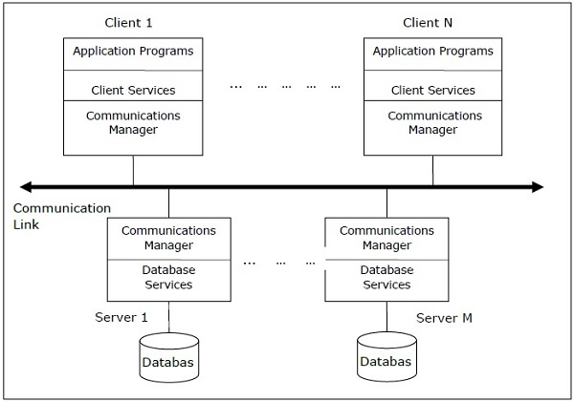

- Peer- to-Peer Architecture for DDBMS
In these systems, each peer acts both as a client and a server for imparting database services. The peers share their resource with other peers and co-ordinate their activities.
This architecture generally has four levels of schemas −
- Global Conceptual Schema − Depicts the global logical view of data.
- Local Conceptual Schema − Depicts logical data organization at each site.
- Local Internal Schema − Depicts physical data organization at each site.
- External Schema − Depicts user view of data.
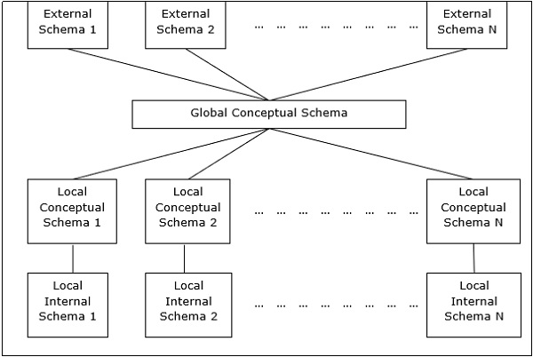
- Multi - DBMS Architectures
This is an integrated database system formed by a collection of two or more autonomous database systems.
Multi-DBMS can be expressed through six levels of schemas −
- Multi-database View Level − Depicts multiple user views comprising of subsets of the integrated distributed database.
- Multi-database Conceptual Level − Depicts integrated multi-database that comprises of global logical multi-database structure definitions.
- Multi-database Internal Level − Depicts the data distribution across different sites and multi-database to local data mapping.
- Local database View Level − Depicts public view of local data.
- Local database Conceptual Level − Depicts local data organization at each site.
- Local database Internal Level − Depicts physical data organization at each site.
There are two design alternatives for multi-DBMS −
- Model with multi-database conceptual level.
- Model without multi-database conceptual level.
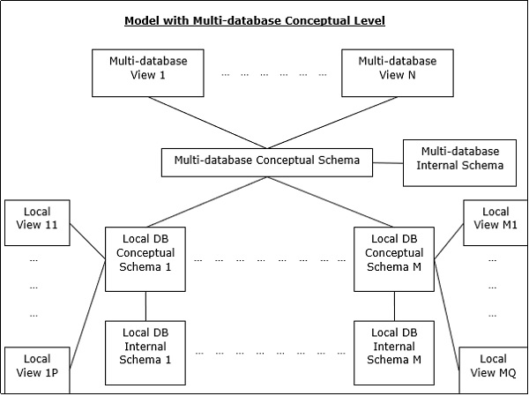
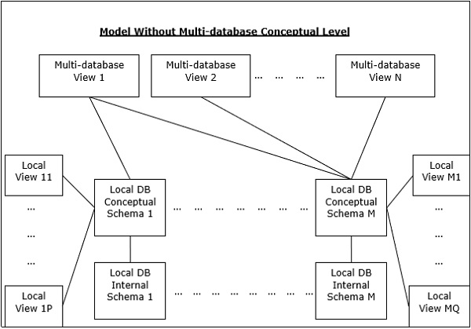

Distributed Database Design: Alternative Design Strategies
The distribution design alternatives for the tables in a DDBMS are as follows −
- Non-replicated and non-fragmented
- Fully replicated
- Partially replicated
- Fragmented
- Mixed
- Non-replicated & Non-fragmented: - In this design alternative, different tables are placed at different sites. Data is placed so that it is at a close proximity to the site where it is used most. It is most suitable for database systems where the percentage of queries needed to join information in tables placed at different sites is low. If an appropriate distribution strategy is adopted, then this design alternative helps to reduce the communication cost during data processing.

- Fully Replicated: - In this design alternative, at each site, one copy of all the database tables is stored. Since, each site has its own copy of the entire database, queries are very fast requiring negligible communication cost. On the contrary, the massive redundancy in data requires huge cost during update operations. Hence, this is suitable for systems where a large number of queries is required to be handled whereas the number of database updates is low.

- Partially Replicated: - Copies of tables or portions of tables are stored at different sites. The distribution of the tables is done in accordance to the frequency of access. This takes into consideration the fact that the frequency of accessing the tables vary considerably from site to site. The number of copies of the tables (or portions) depends on how frequently the access queries execute and the site which generate the access queries.

- Fragmented: - In this design, a table is divided into two or more pieces referred to as fragments or partitions, and each fragment can be stored at different sites. This considers the fact that it seldom happens that all data stored in a table is required at a given site. Moreover, fragmentation increases parallelism and provides better disaster recovery. Here, there is only one copy of each fragment in the system, i.e. no redundant data.
The three fragmentation techniques are −
- Vertical fragmentation
- Horizontal fragmentation
- Hybrid fragmentation

Advantages of Fragmentation
- Since data is stored close to the site of usage, efficiency of the database system is increased.
- Local query optimization techniques are sufficient for most queries since data is locally available.
- Since irrelevant data is not available at the sites, security and privacy of the database system can be maintained.

Disadvantages of Fragmentation
- When data from different fragments are required, the access speeds may be very low.
- In case of recursive fragmentations, the job of reconstruction will need expensive techniques.
- Lack of back-up copies of data in different sites may render the database ineffective in case of failure of a site.

Vertical Fragmentation: - In vertical fragmentation, the fields or columns of a table are grouped into fragments. In order to maintain reconstructiveness, each fragment should contain the primary key field(s) of the table. Vertical fragmentation can be used to enforce privacy of data.
For example, let us consider that a University database keeps records of all registered students in a Student table having the following schema.

STUDENT
Regd_No | Name | Course | Address | Semester | Fees | Marks
Now, the fees details are maintained in the accounts section. In this case, the designer will fragment the database as follows −
CREATE TABLE STD_FEES AS
SELECT Regd_No, Fees
FROM STUDENT;

Horizontal Fragmentation: - Horizontal fragmentation groups the tuples of a table in accordance to values of one or more fields. Horizontal fragmentation should also confirm to the rule of reconstructiveness. Each horizontal fragment must have all columns of the original base table.
For example, in the student schema, if the details of all students of Computer Science Course needs to be maintained at the School of Computer Science, then the designer will horizontally fragment the database as follows −
CREATE COMP_STD AS
SELECT * FROM STUDENT
WHERE COURSE = "Computer Science";

Hybrid Fragmentation: - In hybrid fragmentation, a combination of horizontal and vertical fragmentation techniques are used. This is the most flexible fragmentation technique since it generates fragments with minimal extraneous information. However, reconstruction of the original table is often an expensive task.
Hybrid fragmentation can be done in two alternative ways −
- At first, generate a set of horizontal fragments; then generate vertical fragments from one or more of the horizontal fragments.
- At first, generate a set of vertical fragments; then generate horizontal fragments from one or more of the vertical fragments.
- Mixed Distribution: - This is a combination of fragmentation and partial replications. Here, the tables are initially fragmented in any form (horizontal or vertical), and then these fragments are partially replicated across the different sites according to the frequency of accessing the fragments.

Distribution Design issues

Distribution Design Issues in Distributed Databases
Designing a Distributed Database Management System (DDBMS) presents several challenges. Properly addressing these issues ensures efficiency, reliability, and consistency in a distributed environment.

Key Issues in Distributed Database Design

1. Data Fragmentation
- Challenge: Deciding how to divide the database into smaller fragments while ensuring efficiency.
- Impact: Poor fragmentation can lead to inefficient query execution, increased data access time, and higher communication costs.
- Solution: Use appropriate fragmentation techniques (horizontal, vertical, or hybrid) based on access patterns.

2. Data Replication
- Challenge: Determining the optimal level of replication to balance availability, consistency, and storage costs.
- Impact: Too much replication increases storage overhead, while too little can reduce availability and performance.
- Solution: Implement selective replication based on read-to-write ratios and access frequency.

3. Data Allocation
- Challenge: Deciding where to store each fragment to minimize access costs and maintain performance.
- Impact: Poor allocation can lead to high communication overhead and inefficient distributed query execution.
- Solution: Use cost-based allocation strategies that consider network latency, query distribution, and data dependencies.

4. Distributed Query Processing and Optimization
- Challenge: Executing queries across multiple sites efficiently.
- Impact: Without optimization, query execution can suffer from high latency, excessive data transfer, and increased response time.
- Solution: Implement distributed query optimization techniques, such as semi-joins, data locality, and cost-based optimization.

5. Distributed Transaction Management
- Challenge: Ensuring ACID (Atomicity, Consistency, Isolation, Durability) properties across multiple sites.
- Impact: Without proper transaction control, inconsistencies and data integrity issues can arise.
- Solution: Use protocols like Two-Phase Commit (2PC) and Three-Phase Commit (3PC) to ensure global transaction consistency.

6. Concurrency Control
- Challenge: Managing simultaneous transactions across distributed sites.
- Impact: Uncontrolled concurrency can lead to deadlocks, lost updates, and data inconsistencies.
- Solution: Implement concurrency control mechanisms like distributed locking, timestamp ordering, and optimistic concurrency control.

7. Deadlock Management
- Challenge: Detecting and resolving deadlocks across multiple sites.
- Impact: Without proper deadlock handling, transactions may become stuck indefinitely, reducing system throughput.
- Solution: Use centralized or distributed deadlock detection and resolution techniques like wait-die and wound-wait.

8. Reliability and Fault Tolerance
- Challenge: Ensuring the system continues to function even in case of failures.
- Impact: Node failures, network failures, and crashes can lead to data loss or inconsistency.
- Solution: Implement checkpointing, logging, and replication strategies for failover recovery.

9. Security and Access Control
- Challenge: Protecting sensitive data from unauthorized access across distributed sites.
- Impact: Inadequate security measures can lead to data breaches, unauthorized modifications, and loss of confidentiality.
- Solution: Implement encryption, authentication, role-based access control, and secure communication
- protocols.

10. Network Dependency and Communication Overhead
- Challenge: Managing the dependency on network infrastructure for data retrieval and transaction execution.
- Impact: High communication overhead can degrade performance and increase costs.
- Solution: Optimize data distribution and minimize inter-site communication through caching and query optimization techniques.

Allocation
It is the process to decide where exactly you want to store the data in the database. Also involves the decision as to which data type of data has to be stored at what particular location. Three main types of data allocation are centralized, partitioned, and replicated.
Centralises: Entire database is stored at a single site. No data distribution occurs
Partitioned: The database gets divided into different fragments which are stored at several sites.
Replicated: Copies of the database are stored at different locations to access the data.

